# CS 255 System Design Document Template

This template lays out all the different sections that you need to complete for Project Two. Each section has guidance to prompt your thinking. You will need to continually reference the interview transcript as you work to make sure that you are addressing your client’s needs. There is no required length for the final document. Instead the goal is to complete each section based on what your client’s needs are. Remove this note when you are finished, and replace all bracketed text with the relevant information.

## UML Diagrams

### UML Use Case Diagram

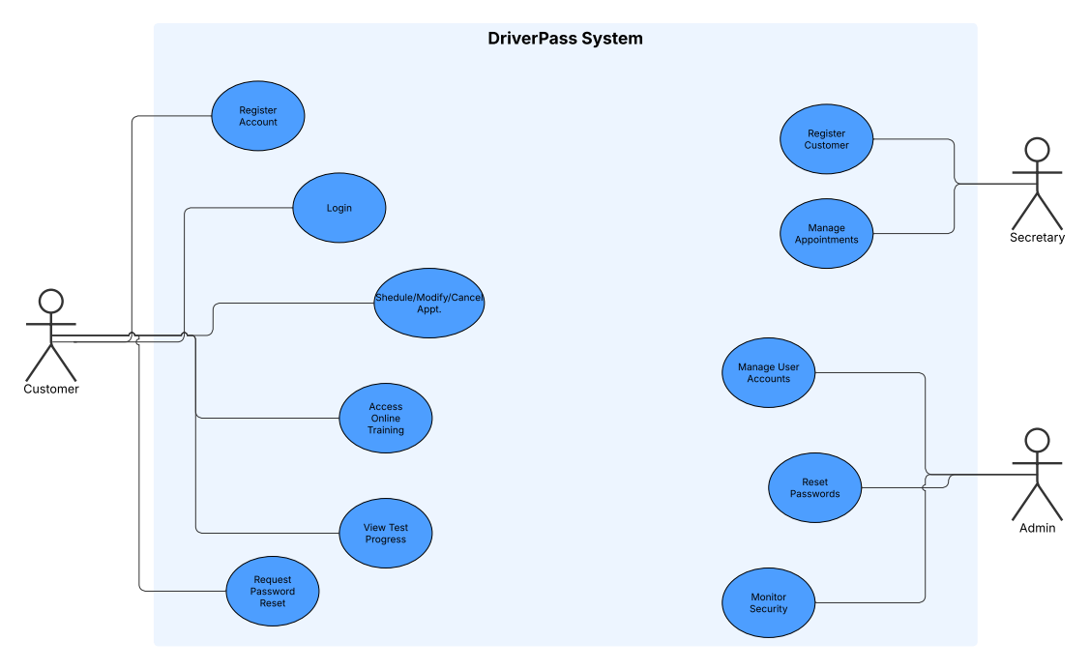

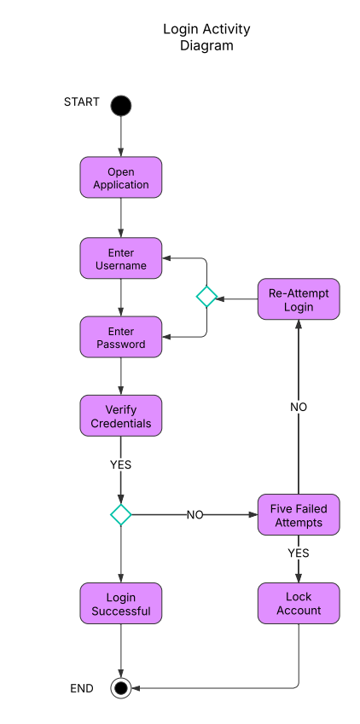

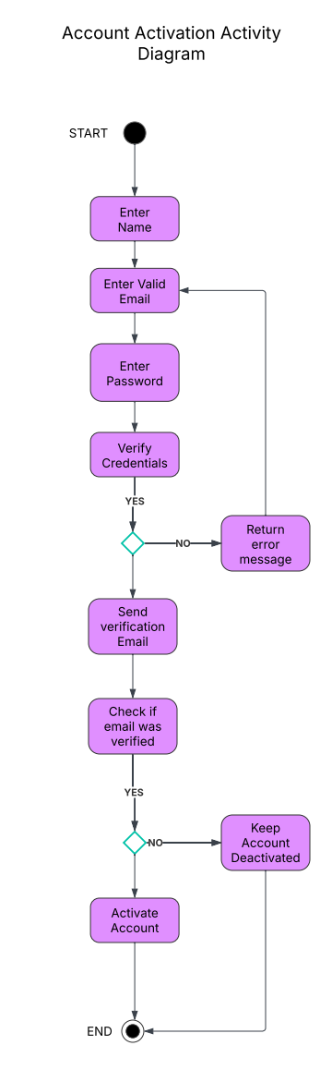

### UML Sequence Diagram

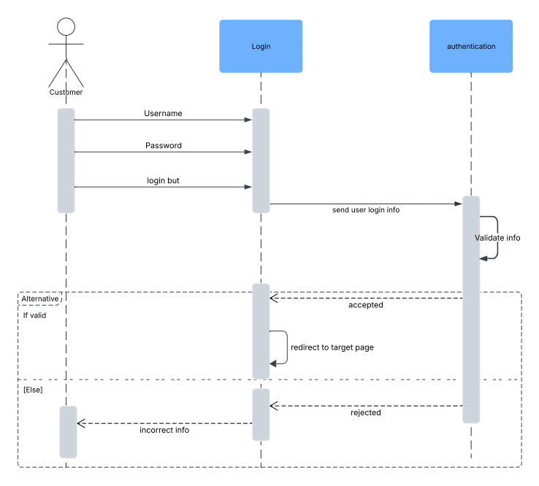

### UML Class Diagram

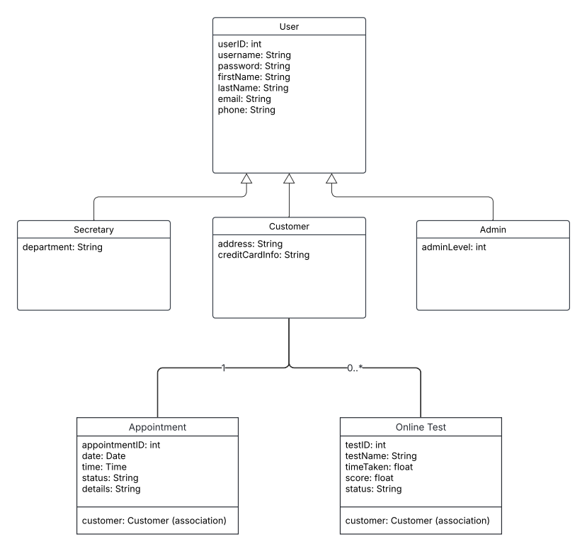

=

## Technical Requirements

Hardware:

* Servers: Use cloud-based application and database servers with load balancers to ensure high availability.
* Client Devices: The system should work on desktops, laptops, tablets, and smartphones.

Software:

* Operating Systems: Backend servers should run on secure, reliable systems like Linux or Windows Server.
* Web Framework: A modern framework (e.g., Spring Boot, Django, or ASP.NET) will be used to build the application.
* Database: A relational database such as MySQL or PostgreSQL will store user, appointment, and test data.
* Security: Secure connections with SSL/TLS and basic firewall protection are required.
* Development Tools: Utilize IDEs (e.g., IntelliJ, Eclipse, Visual Studio), UML tools like Lucidchart, version control (Git), to support development and maintenance.

Infrastructure and Tools:

* Cloud Platform: Host the application on a platform like AWS, Azure, or Google Cloud for scalability.
* Network: Ensure high-speed, reliable internet connectivity for real-time user interactions.
* Monitoring & Backup: Use monitoring tools (e.g., CloudWatch) and regular backup systems to keep data safe and the system running smoothly.